Anyone should be able to setup direct deposit for their pay checks by following the below instructions, if they cannot login, please have them send an email to unions@psav.com for assistance.
Please have them go to https://n21.ultipro.com/Login.aspx?ReturnUrl=/
For the username field, enter your last name and last 4 of your SSN

example: SMITH1425

For your password, enter your birthday, in all numerical –

example: 09241976

You may need to change it once in, depending on if you have never been login before.

Please use something along the lines of

Spring2014@

Or the same type format

In Ultipro, under MENU, MYSELF, PAY then choose DIRECT DEPOSIT, they should be able to set it up.
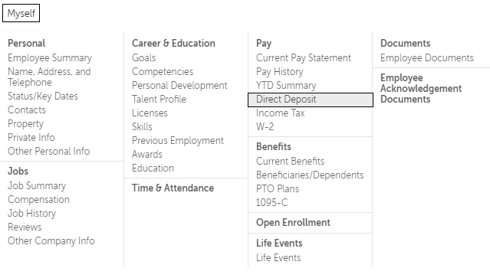
Then they choose Add Direct Deposit, where they will enter their Account number and routing number, hit save and it should take effect by the next payroll cycle.
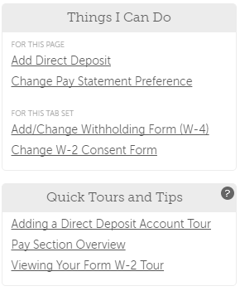

Let me know if you have any questions or have them send me an email if they have any questions or need assistance.

